Church Translation Apps vs Browser Links and Headsets
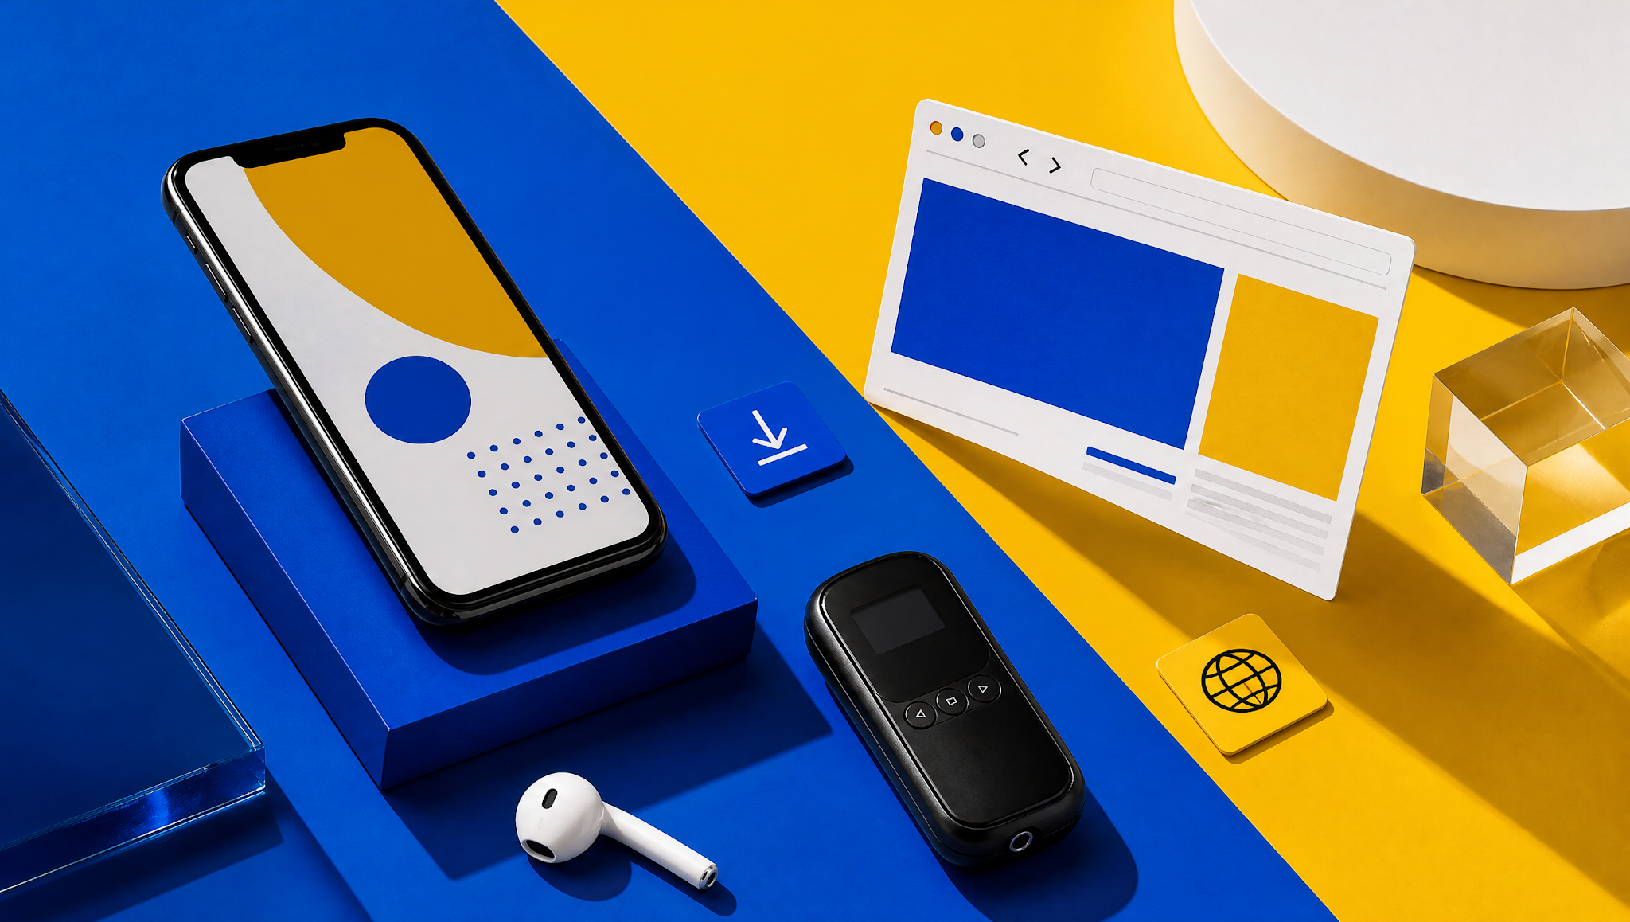
A visitor scans your QR code, picks a language and hears nothing. Think about it. WebKit's own documentation says Safari on iPhone needs a tap before media with sound plays. Small details like that decide Sunday. So what does a church translation app really need to do? And does it have to be an app at all?
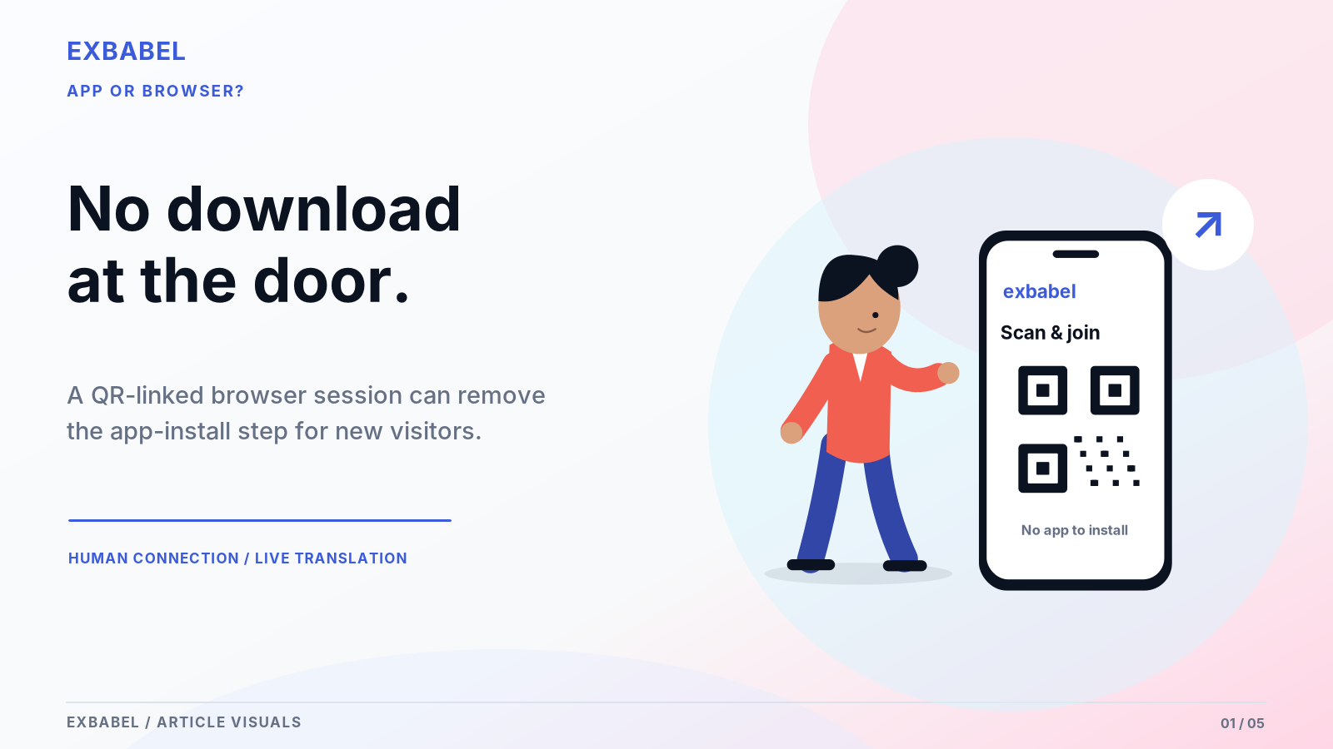

Does a Church Translation App Need to Be an App?
Not always. Churches reach listeners in three ways: an installed phone app, a web page opened by QR code or a receiver with no phone at all. Each has trade-offs. Apps take time to install. Browsers can stumble on audio permissions, especially on iPhone. Receivers need batteries and someone to hand them out. Mixing methods is common. Here are the key points before the walkthrough.

Key Takeaways
- "App" should mean something installed. A page opened by QR code is a browser link.
- First-time visitors make three moves: find the code, pick a language and approve audio.
- Test on a real iPhone and a real Android phone before Sunday.
- Keep receivers or wired earbuds ready for guests without phones.
- Use the checklists below to run the same checks on your own phones.
Let's define the three paths first, because the word "app" causes most of the confusion.

What People Mean by a Church Translation App
Sellers use the word app for almost everything. That muddies the buying decision. Here are the three paths, defined by what a visitor actually has to do.

Installed Phone App
An installed app comes from an app store and lives on the phone. LiveVoice's churches page describes a listener app with iOS, Android and Huawei store links. Installing takes time and storage. Some guests won't do it on a Sunday morning. It's the heaviest ask of a stranger. The upside is a familiar icon they can reopen next week. Check what each app really does when the screen locks.

Web App Opened Through QR Code
Here the visitor scans a code and a page opens in the phone's browser. Nothing installed. Exbabel's guide, Wordly's help pages and Hope Translator's site describe this route, with language choice after the scan. The page is still software, though. It depends on the browser. Fewer steps means fewer places to stall. Calling it an app muddies the comparison. Call it a browser link instead.

Receiver System with No Attendee Phone
Radio receivers hand each listener a small device and an earpiece. ChurchLeaders notes one system can carry up to six languages, with an interpreter and channel for each. Receivers work without the internet. Glossa's guide lists batteries, charging and lost units as the chores. Guests without smartphones may rely on them. Some churches keep a few beside a phone-based option. Check frequency rules for your area before buying.

How Visitors Actually Join
Follow a first-time visitor from the lobby to the first translated word. The steps below draw on vendor documentation. Confirm each one on your own devices.
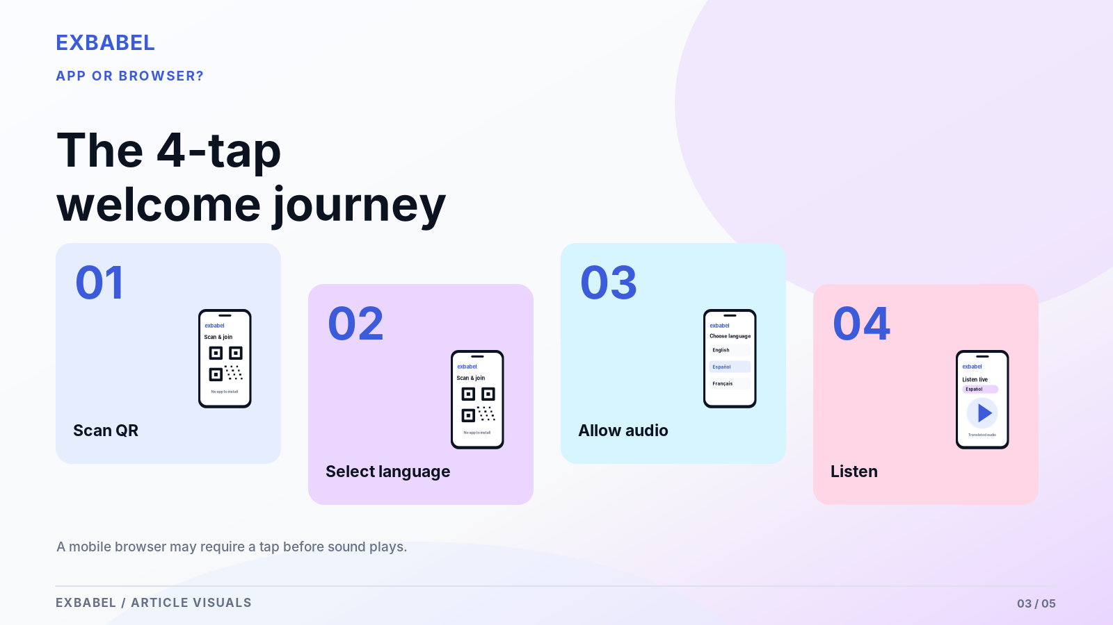

Find the QR Code or Invitation
Visitors can't join what they can't find. Put the code on a slide, in the bulletin and on a sign near the door. Wordly's help page offers a scalable image for screens and a printable PDF with illustrated instructions. Add a short line in plain words: scan this, pick your language. A greeter who points at the sign beats a dozen emails. Repeat the instruction aloud once at the start.

Select Language and Approve Audio
After scanning, the visitor lands on a page and picks a language. Wordly's help describes choosing a language and clicking Attend. Then the phone may ask to allow audio. On iPhone, WebKit documents that media with sound needs a user gesture before it plays. So the first tap matters. Tell visitors to press play or start when they see it. Visitors shouldn't ever have to guess.

Put on Earbuds and Test Volume
Visitors need earbuds or headphones. Otherwise the sound spills into the pew. Bring a few spare wired pairs. Wired pairs never need charging. Ask the visitor to set the phone volume while the pastor is speaking. Remind them to check silent mode too. Exbabel's guide says translation headphones may still help people without smartphones. A greeter can run a ten-second sound check at the door.
Screen | What the visitor sees | Where they can stall | Fix to test
1. Lobby sign | QR code and one-line instruction | Can't find or scan the code | Larger sign near the door; greeter points
2. Language page | List of languages | Doesn't see their language | Check the live menu before service
3. Audio start | Play or start button | Never taps; hears nothing | Say "tap play" on the sign
4. Listening | Translated audio or captions | Volume low; silent mode on | Sound check with a greeter
Want to try the QR flow yourself? Invite your AV team to test Exbabel's QR join and language switching with your own devices through the church translation page. It still needs a working network, so test your Wi-Fi and cellular coverage too.

Compare App, Browser and Receiver Workflows
Each path trades convenience for control. Use the notes below to compare them on setup effort, device support and privacy. Test claims on your own phones since versions change.
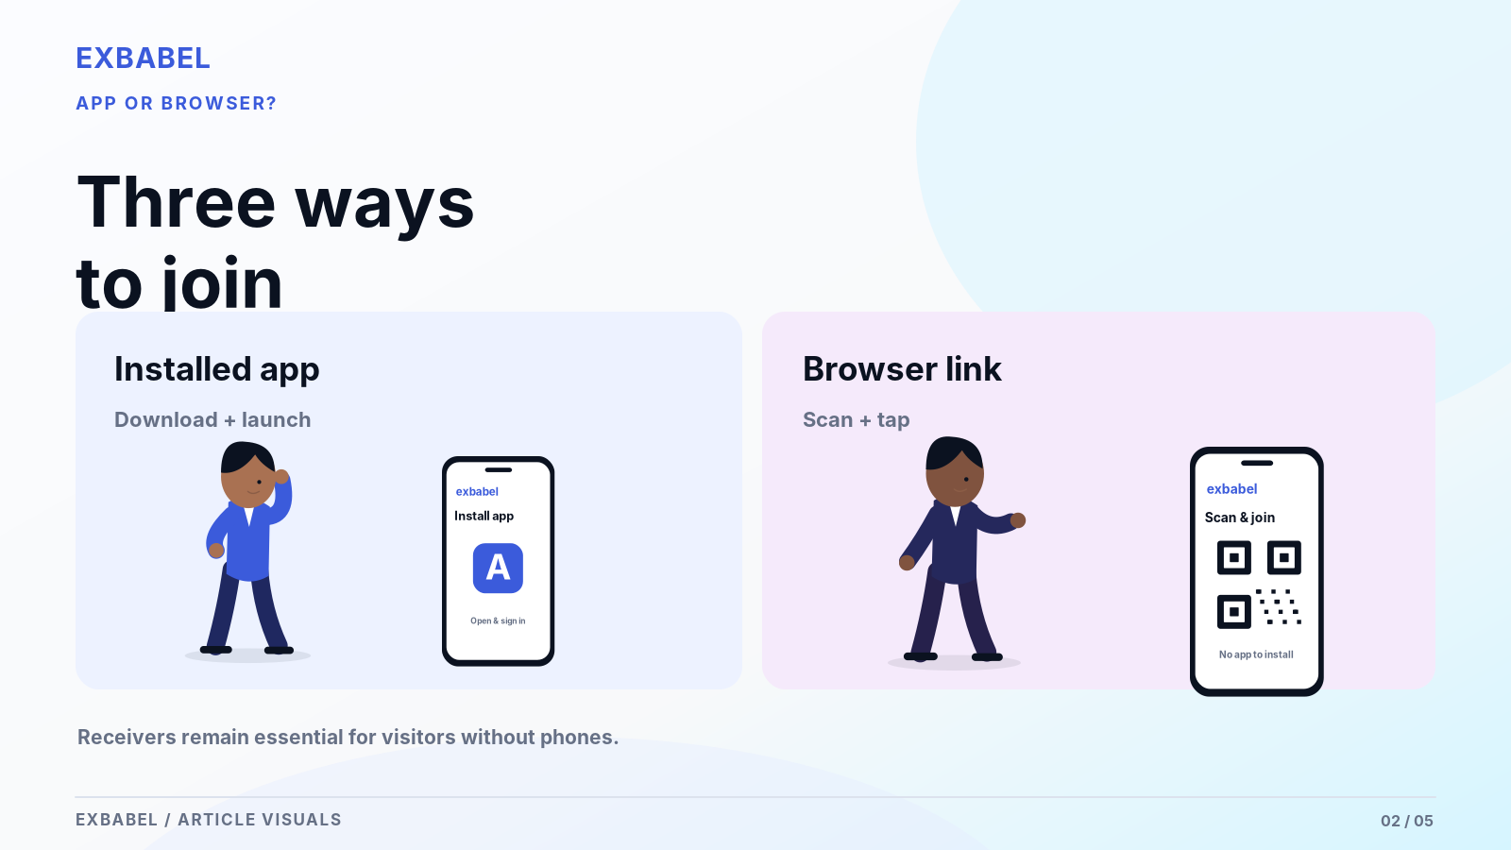

Install Time and Permissions
Apps ask for store access, storage and sometimes notifications. Browser links ask for far less, though audio may need a tap. Receivers need no permissions but do need handing out and collecting. Exbabel's guide says listeners need no app or account. Install time varies by network and device. Fewer permissions mean fewer refusals. Time a first-timer yourself and write the number down.

Browser Compatibility and Battery/Data Use
Browsers differ. WebKit documents the iPhone tap rule. Other browsers have their own habits. No source we read promises that every phone works. Streaming audio uses data and battery. Offer church Wi-Fi and say cellular works too, as Glossa notes. Ask owners of older phones to try the link before the service. Treat "works on every phone" as a warning sign.

Device Privacy and Shared-Device Cases
Some people don't want to install anything or share an email address. A browser page with no account asks for less. Others share one phone or tablet among a family. Receivers avoid personal devices entirely. Read each vendor's privacy terms, because they vary. Tell guests what's recorded. Transcripts exist on several tools. Ask about retention. Some guests are wary of any QR code. That's fair. Explain it simply.
Path | Install | Network needed? | Best fit | Watch out for
Installed app | Yes, from a store | Yes | Regular attenders who want an icon | Store steps; storage; guests who refuse
Browser link (QR) | No (per Exbabel, Wordly and Hope Translator pages) | Yes | Visitors and mixed devices | Audio tap on iPhone; browser differences
Receivers | No | No (radio) | Guests without phones | Batteries, charging, lost units
Hybrid | Mixed | Mixed | Most congregations | Extra volunteer training

Audio, Captions and Translation Accuracy
Translated voice and translated text aren't the same output. They can follow different language lists and different timing. Check the live service menu before you promise anything to a visitor.

Spoken Voice vs Translated Text
Voice suits people who want to look up and listen. Text suits readers and noisy pews. Hope Translator says listeners can read or hear an AI voice. Exbabel says listeners hear AI audio and follow synchronized captions. Offer both when you can. Voice quality varies by language. So listen to each one yourself before you announce it. Neither output wins in every room. Both deserve a test.

Caption Readability
Captions fail when the font is small or the speaker talks fast. Hope Translator mentions adjustable fonts and sizes. Test captions from the back row on a real phone. Check contrast in a dim sanctuary. If captions go on a main screen, give them space and keep Scripture slides clear. Ask a few older members to read a sample and tell you honestly what they see.

Language and Dialect Availability
Language lists change. Voice and text lists can differ. A directory listing for Hope Translator says a few languages are text only. Exbabel's pages disagree on language counts. So we cite none. Ask the vendor to show the menu on a phone, live. Then test each language with a native speaker from your own congregation. Dialects matter too. Ask which variety of Spanish or Arabic the tool speaks.

Sunday Reliability and Network Design
Most Sunday failures are network or permission problems, not translation problems. Plan for both, rehearse them and keep a written fallback. Here are the areas to cover.
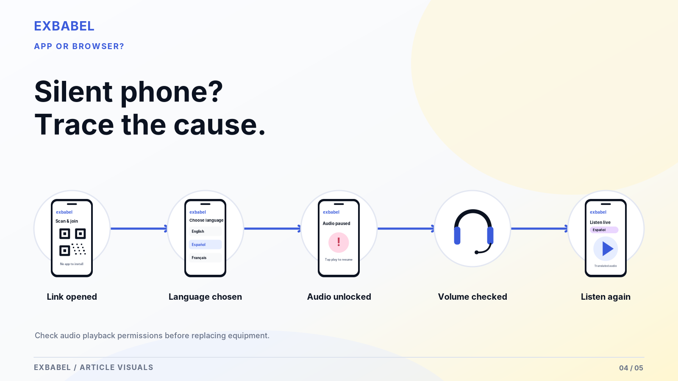

Wi-Fi and Cellular Trade-Offs
Church Wi-Fi can crowd, drop or block guest traffic. Cellular data works without the church network, though coverage varies inside thick walls. Glossa notes listeners without Wi-Fi can use cellular data. Hope Translator recommends a strong connection and Wi-Fi for better processing. Put both options on the sign. Test from the back pew while the room is full. A full room strains a network more than an empty one.

Audio Unlock and Browser Permissions
On iPhone, WebKit documents that media with sound needs a user gesture. A visitor who never taps may see captions move but hear nothing. Build a clear start button into the instructions. Android browsers have their own settings. Test current OS and browser versions on real phones and write the versions down. Don't promise background audio with the screen locked until you've actually tested it.

Recovery After a Dropped Connection
Connections drop. Exbabel's guide mentions failover and buffering but gives no numbers. After a drop, the visitor may need to tap again or reload the page. Test it. Switch Wi-Fi off, wait and switch it on to see what happens. Write the steps on a help card. Teach greeters a simple routine: reload, tap play and check volume. Rehearse it once with volunteers. Time the recovery.
Check | iPhone (version: ___) | Android (version: ___) | Result
Scan QR with default camera
Page loads on church Wi-Fi
Page loads on cellular
Language list shows our languages
Audio starts after one tap
Captions readable at arm's length
Bluetooth earbuds pair and play
Audio resumes after Wi-Fi off and on
Screen lock: does audio continue?

Accessibility and Device Inclusivity
Language access isn't the only access question. Some guests lack phones. Some need captions rather than audio. Use these notes as a starting point, not a legal opinion.
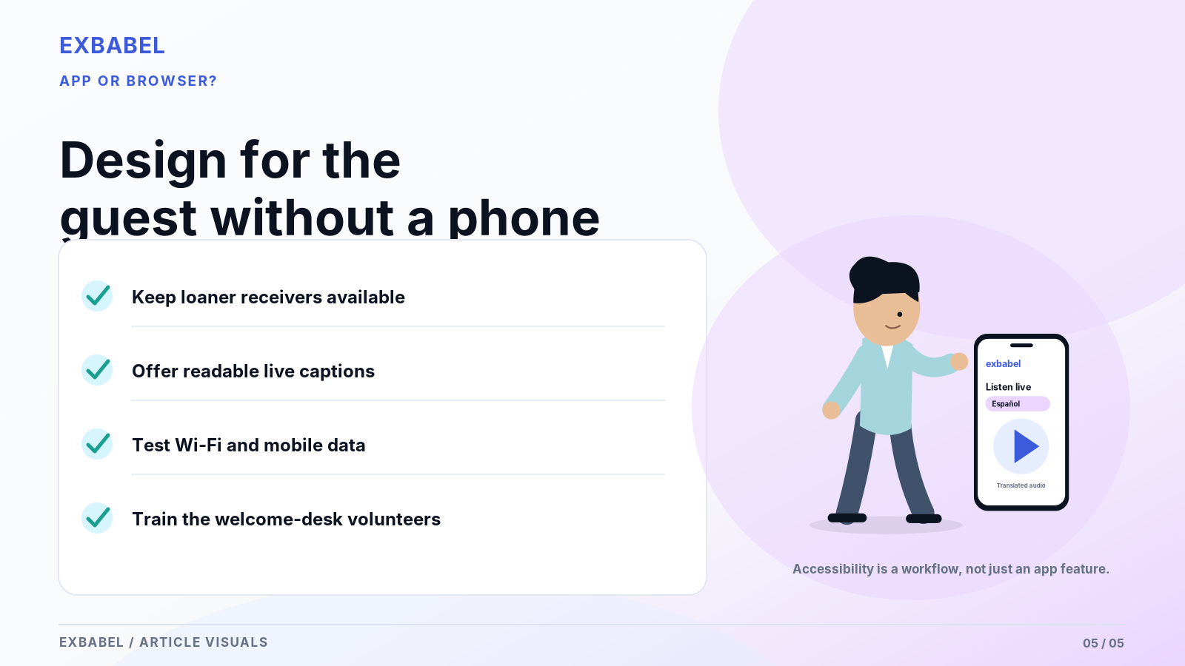

Attendees Without Smartphones
Keep receivers, loaner tablets or wired earbuds for guests without phones. Exbabel's guide says translation headphones may still help them. Glossa suggests some churches keep FM headsets for seniors beside a phone option. Assign a greeter to hand them out and collect them. Don't assume every guest owns a phone or wants to use one. Keep a sign-out sheet if you lend tablets. Mention it in the bulletin too.

Deaf and Hard-of-Hearing Needs
Translated captions help. They aren't the same as qualified sign-language interpreting or real-time captioning by a trained person. The Department of Justice's ADA.gov guidance on effective communication lists captioning, qualified interpreters and assistive listening systems as auxiliary aids. It also says the right aid depends on the person and context. Ask the individual what works. No app settles legal obligations by itself. Plan this before Sunday.

Large-Font Captions and Help Desk Training
Offer large-font captions on phones and on a screen. Train help-desk volunteers to answer two questions fast: how do I join and why can't I hear. Give them a printed card. Practice with a volunteer who has never used the tool. Training takes minutes. It prevents Sunday panic. It also makes guests feel welcome rather than processed. Print the card in large type, too. Laminate it.
Welcome-desk help card: "I can't hear the translation"
- Check your phone volume and silent mode.
- Tap the play or start button on the page.
- Reload the page or scan the code again.
- Try your earbuds in another pair or ask for a loaner.
- Still stuck? Ask a volunteer for a receiver or a seat near a screen with captions.

Choosing Software for Your Congregation
Pick a path by testing, not by reading brochures. A short, honest trial tells you more than a feature list. Here is how to run one.

Trial with First-Time Attendees
Run the trial with people who have never seen the tool. With their consent, watch them join without coaching. Note where they pause. Don't help until they ask. Note the time each step takes. Resist the urge to explain. Use the ten-minute test below. Ask each vendor how to try its product before you commit. Run the trial on the same phones your congregation actually uses.

Volunteer Onboarding and Device Help
Pick two volunteers per service: one at the door and one at the sound desk. Give them the help card and a test phone. Let them practice the dropped-connection routine. Write down who handles complaints during the sermon. Our sermon translation guide covers the audio side. Refresh the training whenever the software updates. Choose people who stay calm under pressure. Give them permission to use the fallback.

Decide: App, Browser, Receivers or Hybrid
Pick by guest reality, not by feature lists. If most visitors carry phones and your network holds, a browser link is lighter. If your regulars like a familiar icon, an app may suit them. If many guests lack phones, keep receivers. Hybrid is common. Our church translation equipment guide compares hardware. The buyer guide covers evaluation. Revisit the choice every year as your congregation changes. Mixing is fine.
Minute | Step | Observe
0 to 1 | Hand a first-time guest a phone and the sign | Do they find the code unaided?
1 to 3 | They scan and choose a language | Where do they pause?
3 to 5 | They start audio and set volume | Do they tap play? Do they hear it?
5 to 7 | Switch language mid-session | Is it obvious how?
7 to 9 | Turn Wi-Fi off and on | Does audio come back?
9 to 10 | Ask what confused them | Write down their words

Scorecard item | Score 1 to 5 | Notes
Joined without help
Time to first translated word
Audio worked on first tap
Captions readable
Recovered after dropped connection
Volunteer could fix a problem in two minutes

Frequently Asked Questions

Does a Church Translation App Require Installation?
Not always. Exbabel's guide, Wordly's help pages and Hope Translator describe QR joining in a browser. LiveVoice describes a listener app. Check each vendor and test it on your own phones.

Can Congregants Use Bluetooth Headphones?
Many phones can send audio to paired earbuds. Pairing, delay and battery drain vary by phone and earbud. Check them on your own devices. Keep wired earbuds as a backup.

Can Translation Work on Church Wi-Fi or Cellular?
Phone-based systems need an internet connection. Glossa notes cellular data works for listeners without Wi-Fi. Hope Translator recommends Wi-Fi for better processing. Test both from the back pew.

What if Attendees Do Not Own a Smartphone?
Keep receivers, loaner devices or wired earbuds ready. Exbabel's guide says translation headphones may still help. Assign a greeter to hand them out and collect them.

Can Captions Be Displayed Without Translated Audio?
Often yes. Hope Translator describes captions on a main screen through OBS or ProPresenter. Exbabel says captions and audio can run together. Confirm the setup with your vendor.
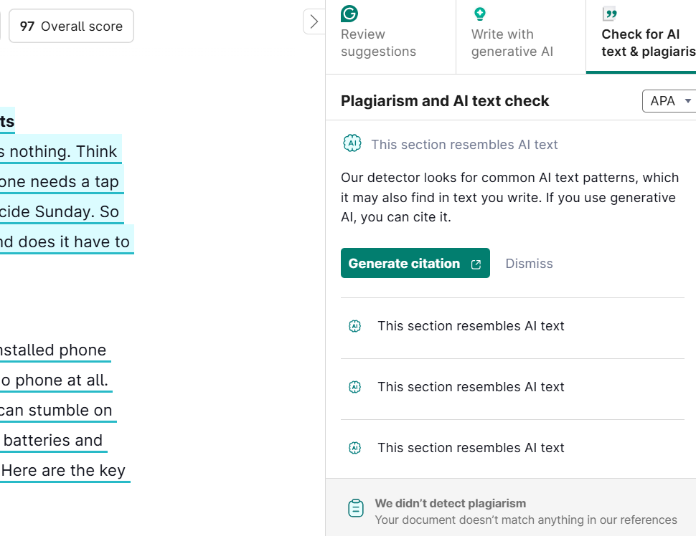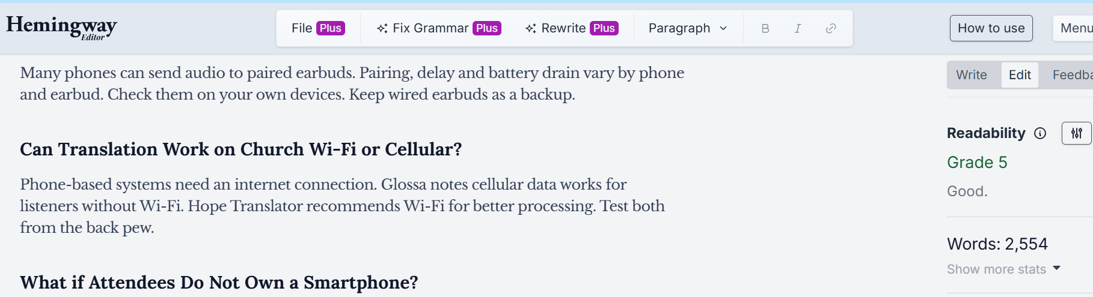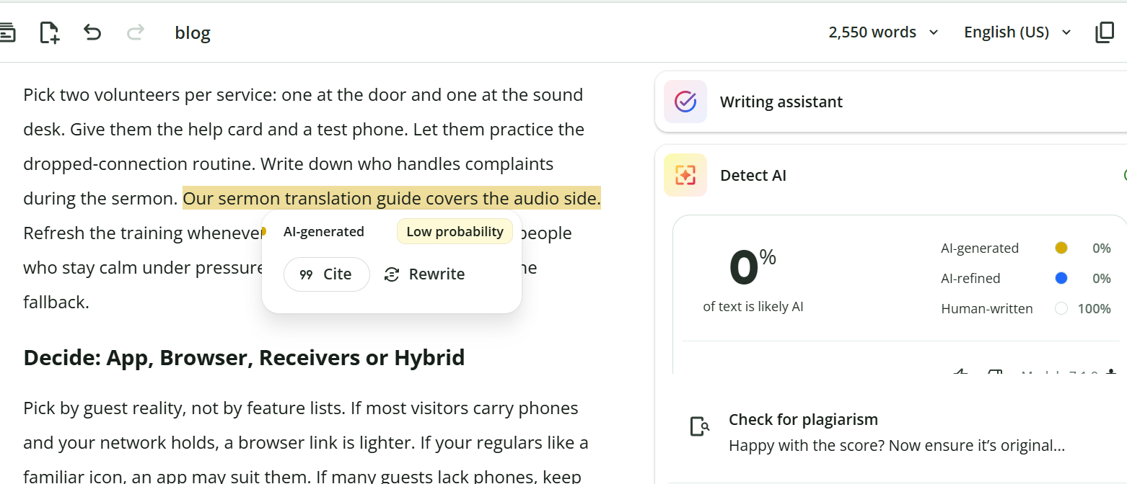

SEO METADATA
- SEO title (52 chars): Church Translation Apps vs Browser Links & Headsets
- Meta description: Compare church translation apps, QR-code browser systems, and listening headsets. Learn what visitors need to connect and what to test before Sunday.
- URL slug: /blog/church-translation-apps/
- Primary keyword: church translation app
- Unique primary search intent: App/system comparison and listener usability. "How do visitors actually join and listen with an app, a browser link or a receiver, and what should we test?" Equipment procurement belongs to /blog/church-translation-equipment/, buyer evaluation to /blog/church-translation-system/, implementation to /blog/sermon-translation-guide/. This page does not compete with the church landing page https://exbabel.com/solutions/churches/.
- Secondary phrases used naturally: church interpreter app, sermon translation app, QR code church translation, browser-based church translation, church translation on smartphones, church translation without app download, church live caption app
- Author disclosure: Published by Exbabel, which sells a browser-based church translation product.
- Suggested schema: Article + FAQPage (use the FAQ items below).
Further reading (external, descriptive anchors):
- WebKit on iOS video policies: why sound needs a tap on iPhone.
- ChurchLeaders on selecting a church translation system: receiver system basics.
- ADA.gov on effective communication: auxiliary aids as context, not a compliance check.
Published by Exbabel.

IMAGE AND RESOURCE RECOMMENDATIONS (with alt text)
- Annotated four-screen first-use journey, iPhone and Android (use screenshots from current devices and versions). Alt: "Four screens showing a visitor scanning a QR code, choosing a language, starting audio and listening."
- Cross-platform QA matrix (the field checklist table) as a downloadable sheet with browser, OS, audio permission, Wi-Fi, LTE/5G and headphone columns.
- Printable welcome-desk help card ("I can't hear the translation") as a PDF.
- Ten-minute usability test and scorecard as a downloadable PDF.
- Photo of a sign near the sanctuary door with QR code and one-line instruction (original, with permission).
- Original evidence to include: one real iPhone and one real Android run with the same language and session; one unaided visitor observed with consent; a documented fallback when browser audio fails after reconnection.

SOURCE LOG (accessed October 18, 2026)
Source | URL | Used for | Claim type
WebKit: New Video Policies for iOS (July 25, 2016) | https://webkit.org/blog/6784/new-video-policies-for-ios/ | Media with sound needs a user gesture on iOS Safari | Platform documentation (dated; re-verify on current iOS)
Wordly help: Downloading QR Codes | https://help.wordly.ai/downloading-qr-codes | QR leads to sign-in page; scan, choose language, click Attend; printable instructions | Vendor documentation
Hope Translator: live sermon translation | https://www.hopetranslator.com/resources/live-sermon-translation | QR broadcast mode, read or AI voice, adjustable fonts, OBS/ProPresenter, Wi-Fi recommendation | Vendor claim
faith.tools listing for Hope Translator | https://faith.tools/app/hope-translator-live-sermon-translation | No download for listeners; some languages text-only | Directory listing (third party)
LiveVoice churches | https://livevoice.io/en/churches | Listener app with iOS, Android and Huawei store links | Vendor claim
ChurchLeaders | https://churchleaders.com/ministry-tech-leaders/404837-how-to-select-the-best-church-translation-system.html | Up to six languages per receiver system | Trade publication
Glossa equipment guide | https://glossa.live/blog/translation-equipment-churches-guide | Battery and charging chores, FM headsets for seniors, cellular data option | Vendor claim
ADA.gov effective communication | https://www.ada.gov/resources/effective-communication/ | Auxiliary aids (captioning, qualified interpreters, assistive listening); right aid depends on person and context | Government guidance (context only)
Exbabel church translation system article | https://exbabel.com/blog/church-translation-system/ | QR/link, no app or dedicated receiver, headphones for those without smartphones, failover and buffering | Exbabel documentation (re-verify)
Exbabel Top 7 Expanded SEO Editorial Briefs (Brief 07) | Client brief | Outline, guardrails, CTA rule | Client brief
Deliberately not used: the "about one second for captions versus two seconds for voice" figures and "200+ languages" and "30-day free trial" statements from Exbabel's existing article (unverified; language counts conflict across Exbabel pages); any latency, battery or data-use figure; any universal iPhone or Android compatibility claim; any claim that an app meets ADA or other legal obligations; Owll and JotMe pages (not read in full).

VERIFICATION CHECKLIST
- Attach the iPhone and Android run (same language and session) with OS and browser versions. The WebKit source is from 2016.
- Attach the screenshots from the unaided visitor run.
- Add the documented fallback for failed browser audio after a reconnect to the recovery section.
- Confirm Bluetooth earbud behavior on the test devices and update the FAQ answer if needed.
- Confirm the CTA destination and the current church landing page body (church page used here: https://exbabel.com/solutions/churches/).
- Confirm the three internal blog URLs are live: /blog/church-translation-system/ (existing), /blog/sermon-translation-guide/, /blog/church-translation-equipment/.
- Have a church AV director and a deaf or hard-of-hearing community member review the accessibility section; ask an accessibility professional about legal wording.
- Re-check LiveVoice, Wordly and Hope Translator pages on the publication date.
- Build the downloadable help card, QA matrix and usability test.

